Technical Specification
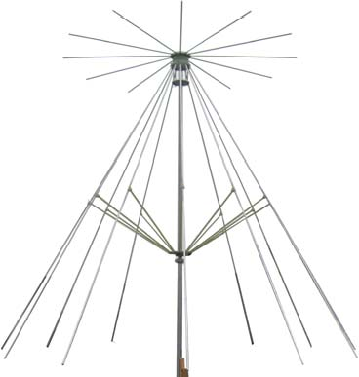
Frequency Range(MHz) | 40 - 500
Gain(dB) | 1 Typ.
Polarization | Linear
VSWR | 2.5:1 Typ.
Power(W) | 300 CW
Connector | N-Female
Size(mm) Φ x H | Φ2289x2377
Net Weight(Kg) | 8.57 Around

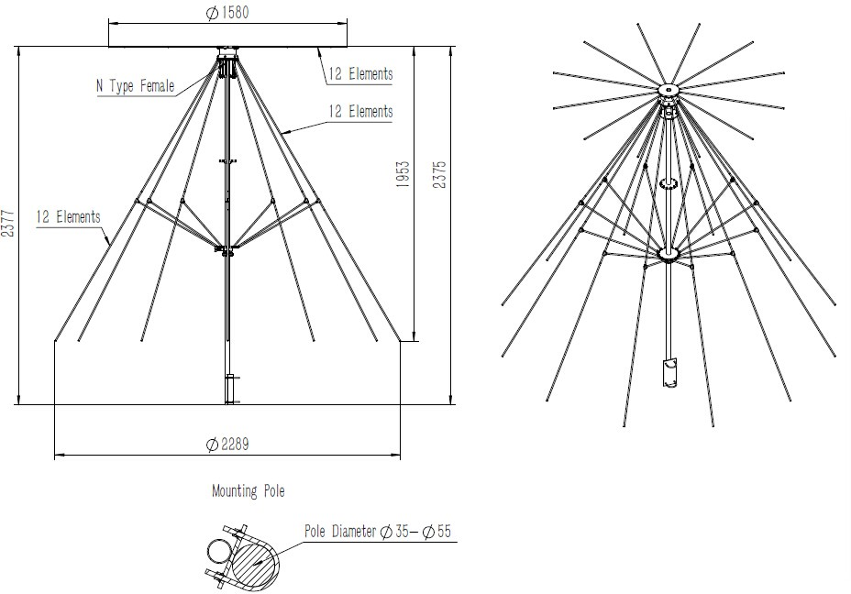
Outline Drawing (Size: mm)

AINFO Inc. Page 1 of 4

China(Beijing): | Tel: (+86) 10-6266-7326, | (+86) 10-6266-7327 | Fax: (+86) 10-6266-7379
China(Chengdu): | Tel: (+86) 28-8519-2786, | (+86) 28-8519-3044 | Fax: (+86) 28-8519-3068 | Website: www.ainfoinc.com
USA : | Tel: (+1) 949-346-7326, | (+1) 949-639-9660 | Fax: (+1) 949-639-9659 | Email: sales@ainfoinc.com

Test Results
- Gain

10
8
Gain(dBi)
6
4
2
0
0 50 100 150 200 250 300 350 400 450 500

Frequency(MHz)

- Antenna Factor

25
Antenna Factor(dB/m)
20
15
10
5
0
0 50 100 150 200 250 300 350 400 450 500

Frequency(MHz)

AINFO Inc. Page 2 of 4

China(Beijing): | Tel: (+86) 10-6266-7326, | (+86) 10-6266-7327 | Fax: (+86) 10-6266-7379
China(Chengdu): | Tel: (+86) 28-8519-2786, | (+86) 28-8519-3044 | Fax: (+86) 28-8519-3068 | Website: www.ainfoinc.com
USA : | Tel: (+1) 949-346-7326, | (+1) 949-639-9660 | Fax: (+1) 949-639-9659 | Email: sales@ainfoinc.com

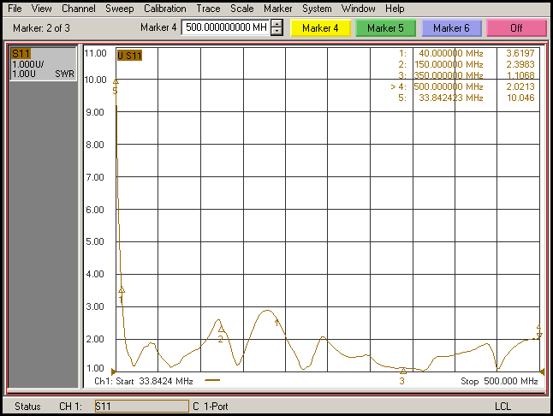
- VSWR

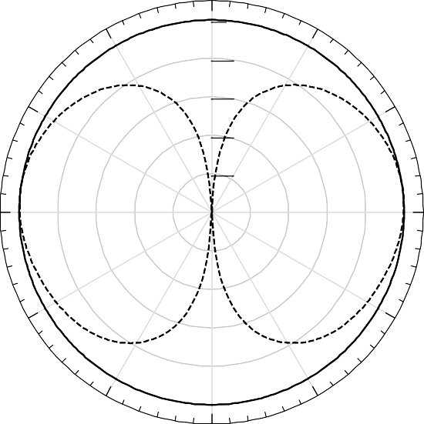
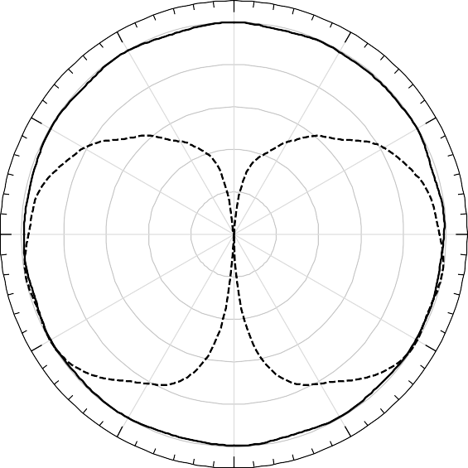
- Pattern
Frequency: 40MHz |  |  |  | Frequency:100MHz
 | 0 |  |  |  | 0
-30 | 0.00 | 30 |  | -30 | 0.00 | 30
 | -10.00 |  |  |  | -10.00
-60 | -20.00 | 60 |  | -60 | -20.00 | 60
 | -30.00 |  |  |  | -30.00
 | -40.00 |  |  |  | -40.00
-90 |  |  | 90 | -90 |  |  | 90
-120 |  | 120 |  | -120 |  | 120
-150 |  | 150 |  | -150 |  | 150
 | -180 |  |  |  | -180
H-Plane ——— |  | E-Plane - - - - - |  | H-Plane ——— |  | E-Plane - - - - -

AINFO Inc. Page 3 of 4

China(Beijing): | Tel: (+86) 10-6266-7326, | (+86) 10-6266-7327 | Fax: (+86) 10-6266-7379
China(Chengdu): | Tel: (+86) 28-8519-2786, | (+86) 28-8519-3044 | Fax: (+86) 28-8519-3068 | Website: www.ainfoinc.com
USA : | Tel: (+1) 949-346-7326, | (+1) 949-639-9660 | Fax: (+1) 949-639-9659 | Email: sales@ainfoinc.com

Frequency: 200MHz |  |  |  | Frequency: 300MHz
 | 0 |  |  |  | 0
-30 | 0.00 | 30 |  | -30 | 0.00 | 30
 | -10.00 |  |  |  | -10.00
-60 | -20.00 | 60 |  | -60 | -20.00 | 60
 | -30.00 |  |  |  | -30.00
 | -40.00 |  |  |  | -40.00
-90 |  |  | 90 | -90 |  |  | 90
-120 |  | 120 |  | -120 |  | 120
-150 |  | 150 |  | -150 |  | 150
 | -180 |  |  |  | -180
H-Plane ——— |  | E-Plane - - - - - |  | H-Plane ——— |  | E-Plane - - - - -

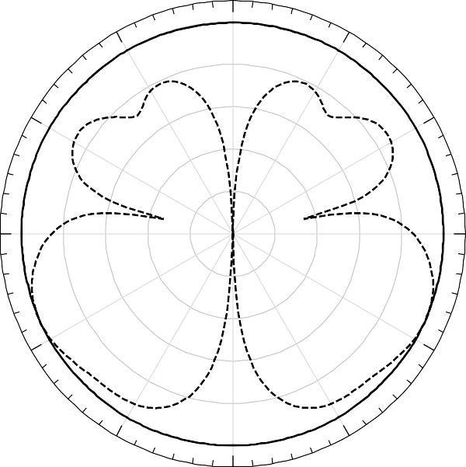
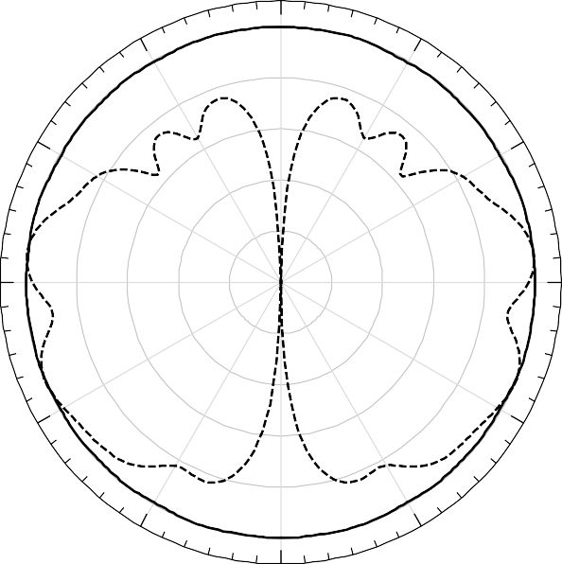
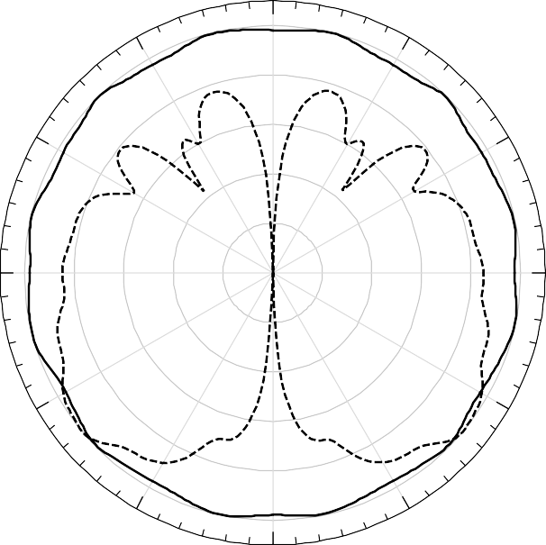
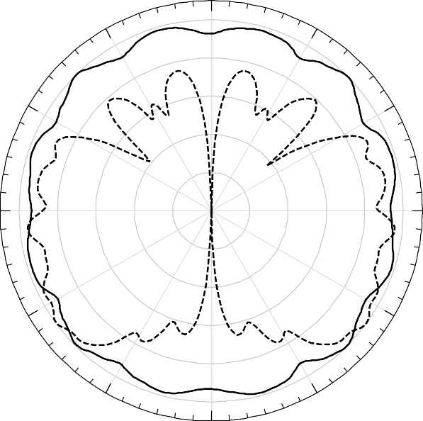
T

Frequency: 400MHz |  |  |  |  | Frequency: 500MHz
 | 0 |  |  |  |  | 0
-30 | 0.00 | 30 |  |  | -30 | 0.00 | 30
 | -10.00 |  |  |  |  | -10.00
-60 | -20.00 |  | 60 |  | -60 | -20.00 |  | 60
 | -30.00 |  |  |  |  | -30.00
 | -40.00 |  |  |  |  | -40.00
-90 |  |  |  | 90 | -90 |  |  |  | 90
-120 |  |  | 120 |  | -120 |  |  | 120
-150 |  | 150 |  |  | -150 |  | 150
 | -180 |  |  |  |  | -180
H-Plane ——— |  | E-Plane - - - - - |  |  | H-Plane ——— |  | E-Plane - - - - -

AINFO Inc. Page 4 of 4

China(Beijing): | Tel: (+86) 10-6266-7326, | (+86) 10-6266-7327 | Fax: (+86) 10-6266-7379
China(Chengdu): | Tel: (+86) 28-8519-2786, | (+86) 28-8519-3044 | Fax: (+86) 28-8519-3068 | Website: www.ainfoinc.com
USA : | Tel: (+1) 949-346-7326, | (+1) 949-639-9660 | Fax: (+1) 949-639-9659 | Email: sales@ainfoinc.com

